**Menstrual Cycle Tracker**

**INDEX**

|  |  |
| --- | --- |
|  | Pg.No |
| 1.Abstract  1.1 Introduction to Menstrual Cycle Tracking:  1.2 Traditional Methods of Menstrual Cycle Tracking  1.3 Challenges with Traditional Methods  1.4 Purpose of the Menstrual Cycle Tracker Website | 2 |
| 2.Background | 3 |
| 3. Summary | 4 |
| 4. Detailed Description  4.1 Technical Specifications  4.2 Algorithms  4.3 User Interface Design | 5-6 |
| 5.Drawings | 7 |
| 6. Conclusion | 8 |

1. **Abstract**

**1.1 Introduction to Menstrual Cycle Tracking:**

Menstrual cycles are a fundamental aspect of reproductive health of a women . The Menstrual Cycle Tracker website (LunaLytics) provides an easy-to-use interface for tracking symptoms, menstrual cycles, and other health information. This website enables users to make informed decisions, obtain insights into their menstrual health, and enhance their general well-being by utilizing the power of contemporary technology.

This website relates to innovative system and method for tracking menstrual cycles through an online platform, hereby referred to as the Menstrual Cycle Tracker Website.

**1.2 Traditional Methods of Menstrual Cycle Tracking:**

Traditional methods of menstrual cycle tracking include bead counting, observation of moon phases, calendar methods, and interpretation of physical signs such as cervical mucus consistency and basal body temperature. These techniques, which have their roots in cultural customs and have been passed down through the decades, gave women important tools for understanding their reproductive cycles and bodies.

**1.3 Challenges with Traditional Methods:**

While traditional tracking methods offer insights into menstrual cycles, they also present challenges such as accuracy, accessibility, and cultural stigma. Additionally, these methods may lack the convenience and flexibility desired by modern women seeking more sophisticated tracking solutions.

**1.4 Purpose of the Menstrual Cycle Tracker Website:**

The Menstrual Cycle Tracker Website represents a modern, user-friendly, and comprehensive solution for menstrual cycle tracking. . The website uses digital technology to give women easy-to-use tools for tracking their menstrual health, forecasting their cycles, and finding support from the community.

1. **Background**

Earlier , women have employed various techniques to track their menstrual cycles, often relying on simple yet effective methods like Calendar Method/ Pen Paper Method, Writing in diary , etc

1. **Summary**

Although traditional monitoring techniques provide information about menstrual periods, there are drawbacks, including issues with accessibility and accuracy. The need for more advanced monitoring choices and technological improvements have prompted a shift towards digital solutions for menstrual cycle tracking as a reaction to these difficulties.

A innovative, friendly, and all-inclusive menstrual cycle monitoring solution is provided by the Menstrual Cycle Tracker Website (LunaLytics). The website provides easy-to-use tools for tracking menstrual health, forecasting cycles, and finding assistance from the community by utilizing digital technologies. In the current digital era, it seeks to enable women to take charge of their reproductive health and wellbeing.

The section highlights how the website serves the various requirements and interests of women all around the world, thereby fostering inclusivity and diversity. It emphasizes how crucial it is to create a safe online space where women can exchange stories, learn from one another, and obtain tools for managing their menstrual health.

1. **Detailed Description**

The Menstrual Cycle Tracker Website is a feature-rich online tool created to make it easier and more enjoyable for users to track their menstrual periods. This section offers a thorough explanation of the website's operation, including with technical details, algorithms, UI design, and other pertinent data.

4.1 Technical Specifications

* Web Architecture:

Node.js with Express.js is used for the back-end of the website, while HTML, CSS, JavaScript, and React.js are used for the front end.

* Security methods: To safeguard user privacy and secure personal information, the website uses industry-standard security procedures.

4.2 Algorithms:

* Cycle Prediction Algorithm: The website utilizes algorithms to predict future menstrual cycles based on users' past cycle data. These algorithms take into account factors such as cycle length, menstrual flow, and any irregularities to provide accurate predictions.
* Symptom Tracking Algorithm: This algorithm examines and compares the symptoms that users report to their menstrual cycles. This aids in the better understanding and management of menstrual health by enabling users to recognize patterns and changes in their symptoms over time.

4.3 User Interface Design:

* + Login/Sign Up page : The login/sign up page serves as the entry point for users to access the website's features. Users are given the choice to either create a new account or log in using their current credentials.The page includes options for social media login (e.g., Google, Facebook) in addition to input fields for password and username/email.  
    In order to register, a new user must enter their email address, password, and possibly other information like gender and age.
  + Survey for Analyzing Dates : The survey page is designed to gather information from users about their menstrual cycle dates and related data.
  + Calendar :The calendar page displays users' menstrual cycle data in a visual format, allowing them to view past and predicted cycle dates, ovulation days, and fertile windows.
  + Nearby Gynecologist : The nearby gynecologist page utilizes location-based services to help users find nearby gynecologists, obstetricians, or women's health clinics.
  + Book Appointment : The book appointment page enables users to schedule appointments with gynecologist directly through the website.

1. **Drawings**

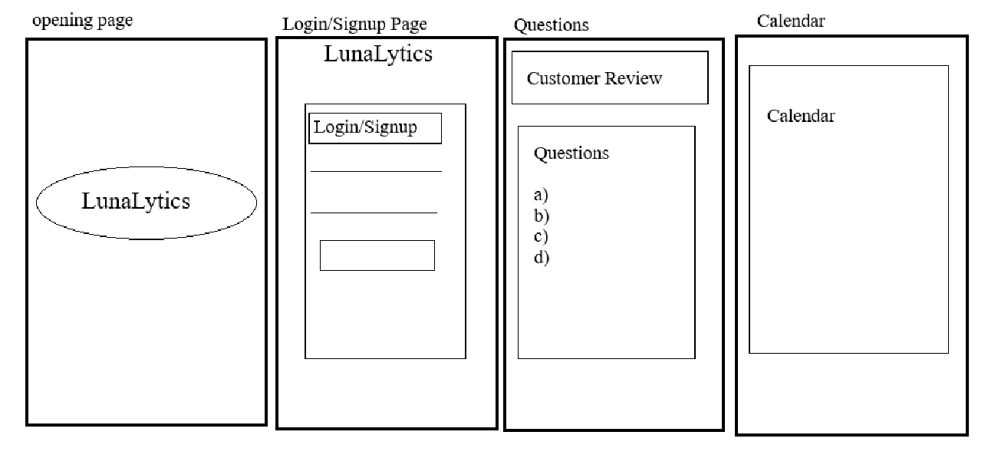

Each page of the website is designed with user convenience, accessibility, and functionality in mind, offering a seamless and intuitive experience for users to track their menstrual health, access educational resources, and connect with healthcare providers as needed.

Here you can effortlessly monitor and manage your menstrual health. Begin by signing up or logging in to access personalized tracking tools. Answer simple questions to provide essential cycle details, enabling personalized insights and predictions. Visualize your cycle with our interactive calendar, tracking period dates, ovulation, and fertility windows. Stay informed with personalized updates on upcoming periods, educational content, and community discussions.

1. **Conclusion :**

In conclusion, Lunlytics provides an innovative method for women to easily monitor and control their menstrual health. Lunlytics' user-friendly interface and extensive feature set enable users to make educated decisions, gain valuable insights into their menstrual cycles, and prioritize their reproductive wellness.